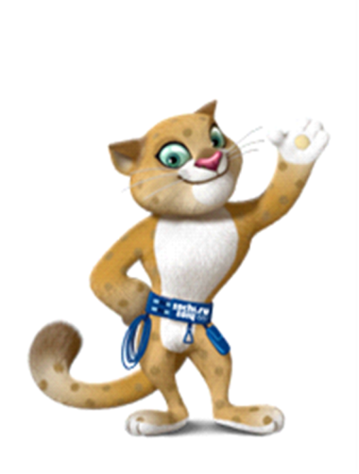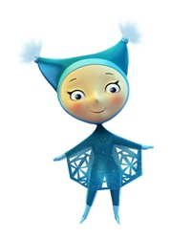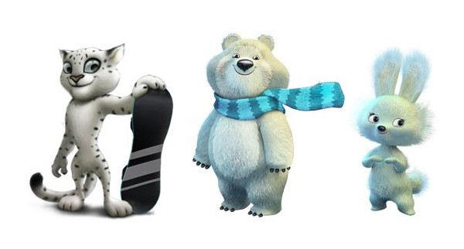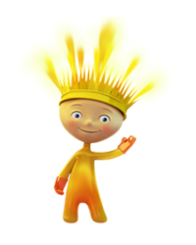

**The Arctic Circle in an ice igloo living white teddy bear . At his house all made of ice and snow : snow shower , bed, computer and even exercise machines .**

**White teddy bear from early childhood brought explorers . It was they who taught him skiing, skating and curling to play . But most of all white like a bear to ride a sled sports . He became the luge and bobsleigh , and his friends - seals and fur seals - with pleasure watching his victories. Now together they organize competitions in these sports , and the long polar night they bored!**

White leopard Barsik - strong, tough beast that lives in the mountains of the Caucasus. White leopard - a connoisseur of mountain slopes and a great climber. He guards the nearest village from the weather, and in his spare time he teaches his friends snowboarding.

**The Hare** is the busiest creature in the winter forest. Her friends are always amazed: just how does she find the time to do so much! For the little doe hare not only studies at the Forest Academy (where she gets excellent grades) and helps her Mum in the family restaurant, “The Forest Dam”, but also takes part in all manner of sporting events. The little doe hare trusts her friends so much that she doesn’t have any secrets. She simply loves sport with all her heart. And she also loves to sing and dance.