Study the two photographs. In a minute be ready to compare and contrast the photographs:
1) give a brief description (action, location)
2) say what the pictures have in common
3) say in what way the pictures are different
4) say which way to save water you'd prefer
5) explain why

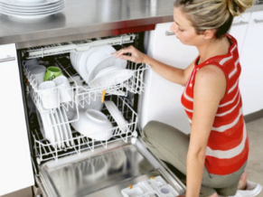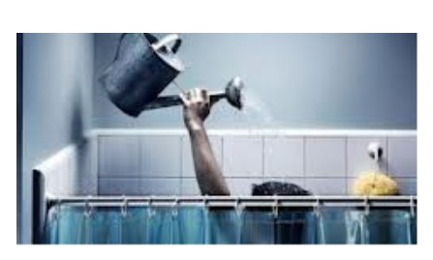

Sample answer:

The problem of saving water has become very important recently. Many people have now realized that we should use the water services which we already have efficiently and wisely.
If we look at these pictures we will see that both of them show us people using water for their needs.
In the first picture a woman is going to wash the dishes in the dishwasher, we see her putting a plate into. In the second picture there is a man who is taking a shower in unusual way - using a watering can.
The striking similarity between these two pictures is that both people are using some ways of saving water.
And the main difference between the pictures is different ways of saving water they are showing. The woman is giving an example how we can save water in the kitchen, she is going to use the full dishwasher not to waste water inefficiently. And the man in the second picture is using a watering can not to let himself waste more water than he needs.
From these two ways of saving water I would prefer to use a dishwasher full and on a short cycle. As for using a "primitive shower" in the bathroom I'd better have a special water-saving showerhead fitted which helps to use less water.
There are of course many other ways to save water in and outside the house, and if we follow these simple rules we all can do our bit for the environment.

Материал подготовлен учителем английского языка высшей категории «МБОУ гимназия №1 г. Челябинска» Наталией Александровной Малышевой

