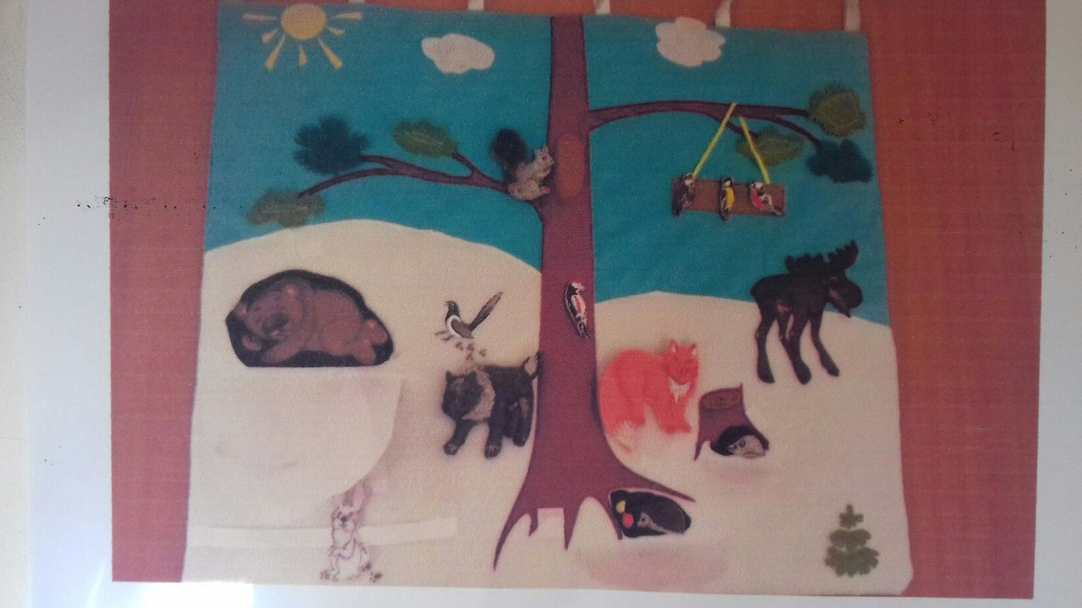

|  |  |
| --- | --- |
| C:\Users\ADMIN\Desktop\Q8VT4vscRls.jpg | C:\Users\ADMIN\Desktop\-xiW6Gr8EHs.jpg |

|  |  |
| --- | --- |
| C:\Users\ADMIN\Desktop\v4NUx3XAt8w.jpg | C:\Users\ADMIN\Desktop\eBOi7rzRZss.jpg |
| C:\Users\ADMIN\Desktop\физ.jpg | C:\Users\ADMIN\Desktop\NI8TbIIgp3k.jpg |

|  |  |
| --- | --- |
|  | C:\Users\ADMIN\Desktop\NI8TbIIgp3k.jpg |